**WIREFRAME DOCUMENTATION**

**APP STORE ANALYSIS**

|  |  |
| --- | --- |
| **Version:** | **1.0** |
| **Last Revised Date:** | **03-11-2021** |
| **Written By:** | **Balaji Mummidi** |

**Contents**

1. **Dataset Overview**
2. **Quick Insights**

1. **Dataset Overview**

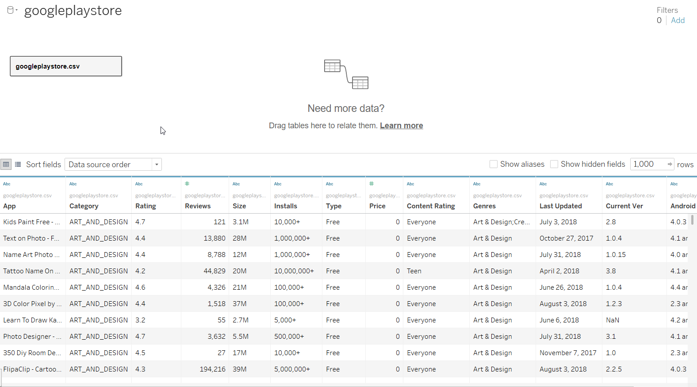

* This page represents the overview of google play store dataset. This dataset consists of names of different apps, rating of apps, size, total number of installs, Genres of the app, category of the app, last updated, app version, content rating of the app.

1. **Quick Insights**

* Quick Insights of the different apps, mostly installed apps, apps that have never been installed, 10 most costliest apps, apps based on content rating, top 5 apps based on content rating etc.. are obtained from the data.

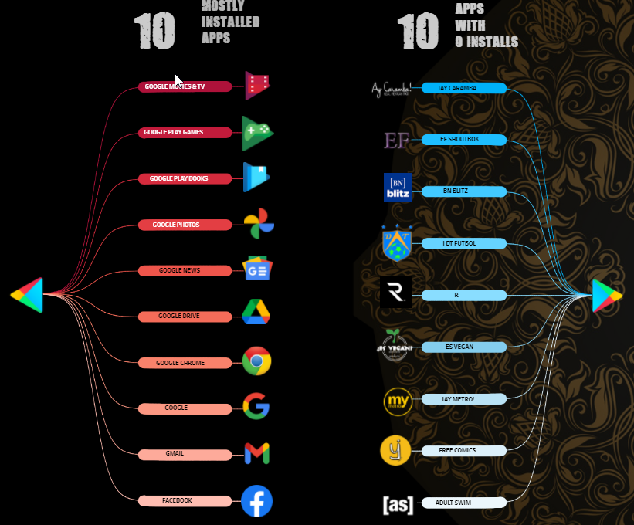

**APPS BASED ON CONTENT RATING**

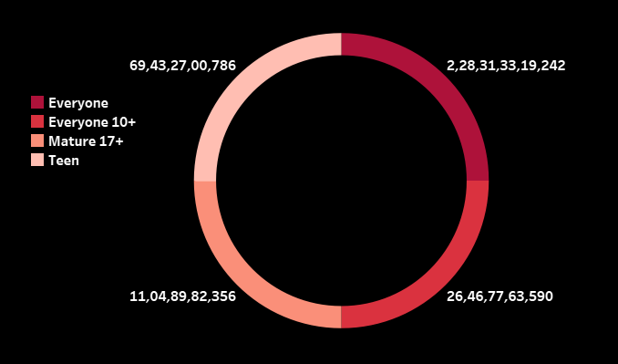

**5 MOSTLY REVIEWED APPS**

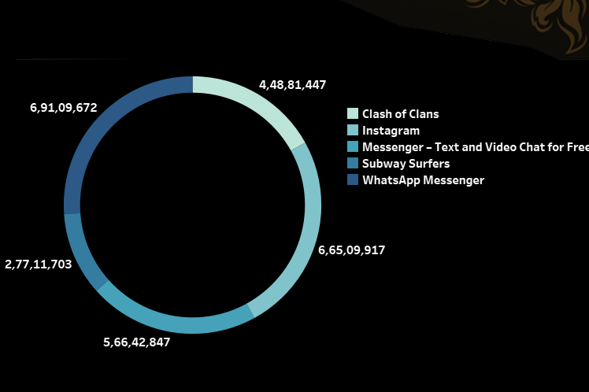

**LEAST 5 APP INSTALLS BASED ON GENRES**

**LEAST 5 APP INSTALLS BASED ON GENRES**

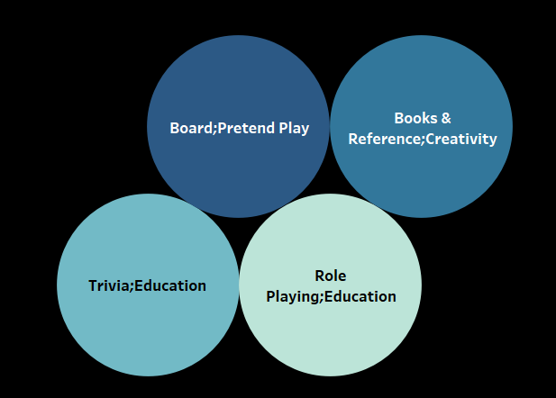

**APP INSTALLS BASED ON CATEGORY**



